Government of Tonga receives USD$8million from the World Bank for Emergency Support following Hunga Tonga Hunga Ha’apai Volcanic Eruption

Nuku’alofa, January 25, 2022 – The Government of Tonga is grateful to the international community for their support and assistance following the Hunga Tonga Hunga Ha’apai Volcanic Eruption that occurred on Saturday 15 January 2022. In particular, to the World Bank for the disbursement of USD$8 million in emergency funding to support the Government response and recovery efforts.
This will allow the Government to respond to the country’s emergency needs, re-establish essential services and utilities, and support help families most affected by the catastrophe (including relief supplies, temporary housing, and income support.)
These funds were channeled through the Tonga Second Resilience Development Policy Operation with a Catastrophe-Deferred Drawdown Option which allows urgent disbursement of funds in the event of a catastrophe. This prepositioned mechanism has allowed Tonga to access rapid financing when most needed.
“As humanitarian efforts and relief supplies and grants to affected families, women and children were delivered within a day following the catastrophe. Immediate drinking water assistance were deployed to the outer islands soon after. The connectivity with our outer islands is underway to be re-established. This rapid cash disbursement will not only respond to the country’s immediate needs but will also allow the Government to plan more confidently following the response and recovery. We are indeed grateful to the World Bank for this timely response”, said Hon. Tatafu Moeaki, Minister for Finance.
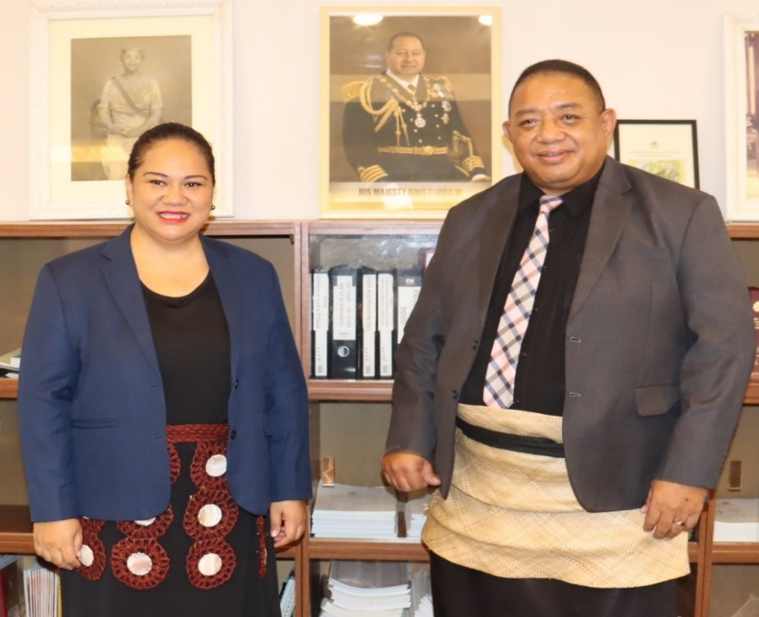
Mrs Natalia Palu latu, WB Liaison Officer, Hon. Tatafu Moeaki, Minister of Finance, Governor of the WB to Tonga

